**Assignment 1**

**Scripts:**

x<-c(-10:10)

x<-x*1

x

plot(x,2*cos(x),col="blue")

**output from R**

|  |
| --- |
| > x<-c(-10:10)  > x<-x*1  > x  [1] -10 -9 -8 -7 -6 -5 -4 -3 -2 -1 0 1 2 3 4 5 6  [18] 7 8 9 10  > plot(x,2*cos(x),col="blue") |
|  |
| |  | | --- | | > | |

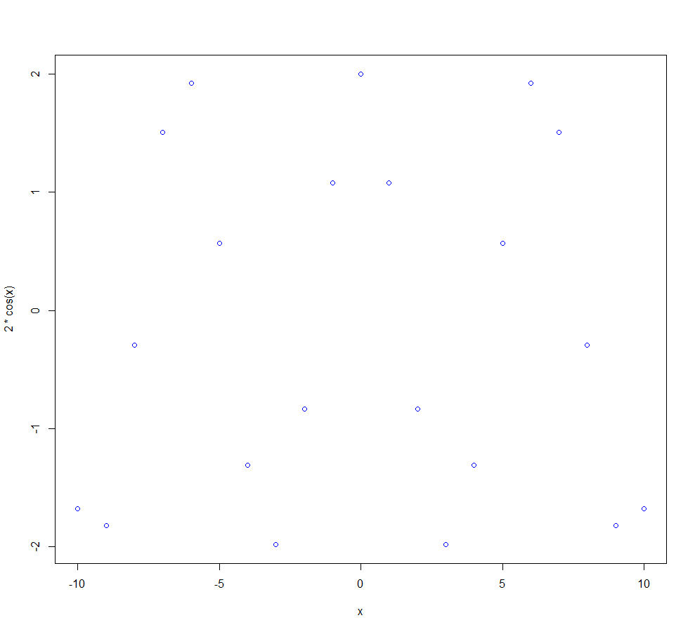

**Assignment 2**

Summary of the mutations identified in the *BRAF* gene.

The data acquisition process:

First of all, go to website <http://www.cbioportal.org/> and then from Select Cancer Study, choose the tcga, and then go to click Thyroid and it would become filled square,

From Select Data Type Priority, click only mutation

And type in *BRAF*, summit it.

<http://www.cbioportal.org/cross_cancer.do?cancer_study_list=&cancer_study_id=all&data_priority=1&case_ids=&patient_case_select=sample&gene_set_choice=user-defined-list&gene_list=BRAF&clinical_param_selection=null&tab_index=tab_visualize&Action=Submit&Action=Submit#crosscancer/overview/1/BRAF/thca_tcga%2Cthca_tcga_pub>

and then click the Thyroid (TCGA pub),

<http://www.cbioportal.org/index.do?tab_index=tab_visualize&cancer_study_id=thca_tcga_pub&genetic_profile_ids_PROFILE_MUTATION_EXTENDED=thca_tcga_pub_mutations&genetic_profile_ids_PROFILE_COPY_NUMBER_ALTERATION=&Z_SCORE_THRESHOLD=2.0&case_set_id=thca_tcga_pub_sequenced&case_ids=&gene_list=BRAF&gene_set_choice=user-defined-list&Action=Submit&show_samples=false&>

download tab-delimited format, input to R program, and then attach it. Generate a graph that show the number of individuals with a mutation at that position.

**Scripts:**

**# the exact distance**

plot(Start.Pos, X.Mut.in.Sample)

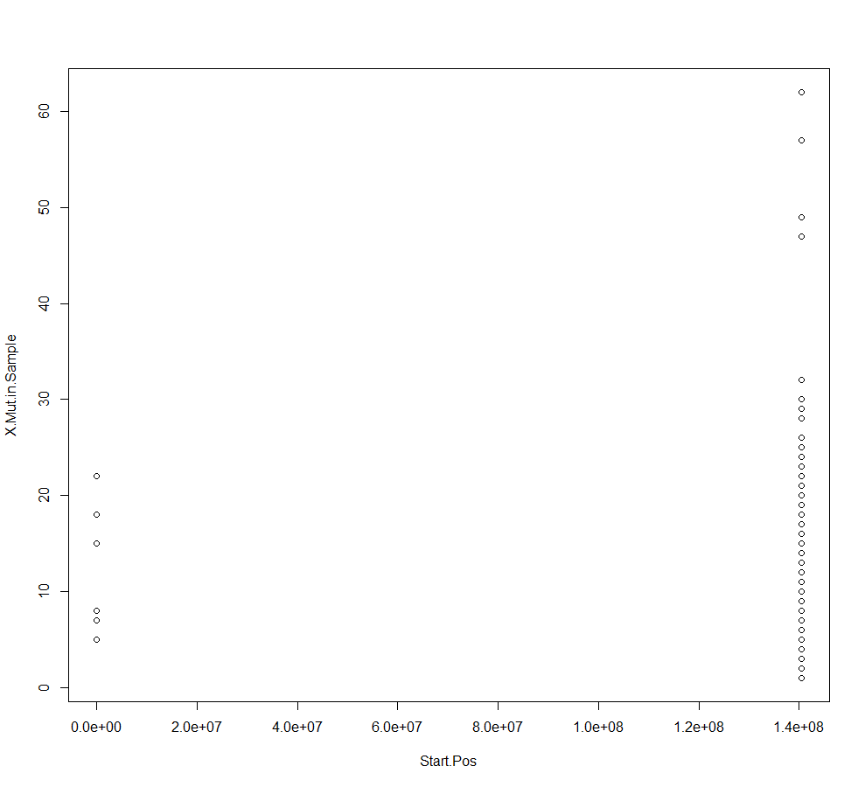

|  |
| --- |
|  |
| |  | | --- | |  | |

**Scripts:**

**#transform the exact distance into factors**

Start.Pos

levels(as.factor(Start.Pos))

plot(as.factor(Start.Pos))

**Output from R:**

> Start.Pos

[1] 140453135 140453136 140453136 140453136 140453136 140453136 140453136 140453136

[9] 140453136 140453136 140453136 140453136 140453136 140453136 140453136 140453136

[17] 140453136 140453136 140453136 140453136 140453136 140453136 140453136 140453136

[25] 140453136 140453136 140453136 140453136 140453136 140453136 140453136 140453136

[33] 140453136 140453136 140453136 140453136 140453136 140453136 140453136 140453136

[41] 140453136 140453136 140453136 140453136 140453136 140453136 140453136 140453136

[49] 140453136 140453136 140453136 140453136 140453136 140453136 140453136 140453136

[57] 140453136 140453136 140453136 140453136 140453136 140453136 140453136 140453136

[65] 140453136 140453136 140453136 140453136 140453136 140453136 140453136 140453136

[73] 140453136 140453136 140453136 140453136 140453136 140453136 140453136 140453136

[81] 140453136 140453136 140453136 140453136 140453136 140453136 140453136 140453136

[89] 140453136 140453136 140453136 140453136 140453136 140453136 140453136 140453136

[97] 140453136 140453136 140453136 140453136 140453136 140453136 140453136 140453136

[105] 140453136 140453136 140453136 140453136 140453136 140453136 140453136 140453136

[113] 140453136 140453136 140453136 140453136 140453136 140453136 140453136 140453136

[121] 140453136 140453136 140453136 140453136 140453136 140453136 140453136 140453136

[129] 140453136 140453136 140453136 140453136 140453136 140453136 140453136 140453136

[137] 140453136 140453136 140453136 140453136 140453136 140453136 140453136 140453136

[145] 140453136 140453136 140453136 140453136 140453136 140453136 140453136 140453136

[153] 140453136 140453136 140453136 140453136 140453136 140453136 140453136 140453136

[161] 140453136 140453136 140453136 140453136 140453136 140453136 140453136 140453136

[169] 140453136 140453136 140453136 140453136 140453136 140453136 140453136 140453136

[177] 140453136 140453136 140453136 140453136 140453136 140453136 140453136 140453136

[185] 140453136 140453136 140453136 140453136 140453136 140453136 140453136 140453136

[193] 140453136 140453136 140453136 140453136 140453136 140453136 140453136 140453136

[201] 140453136 140453136 140453136 140453136 140453136 140453136 140453136 140453136

[209] 140453136 140453136 140453136 140453136 140453136 140453136 140453136 140453136

[217] 140453136 140453136 140453136 140453136 140453136 140453136 140453136 140453136

[225] 140453136 140453136 140453136 140453136 140453136 140453136 140453136 140453136

[233] 140453136 140453136 140453136 140453134 -1 -1 -1 -1

[241] -1 -1 140477827 140477832 140453194 140453164

|  |
| --- |
| > levels(Start.Pos)  NULL  > levels(as.factor(Start.Pos))  [1] "-1" "140453134" "140453135" "140453136" "140453164" "140453194"  [7] "140477827" "140477832"  > plot(as.factor(Start.Pos)) |
|  |
| |  | | --- | |  | |